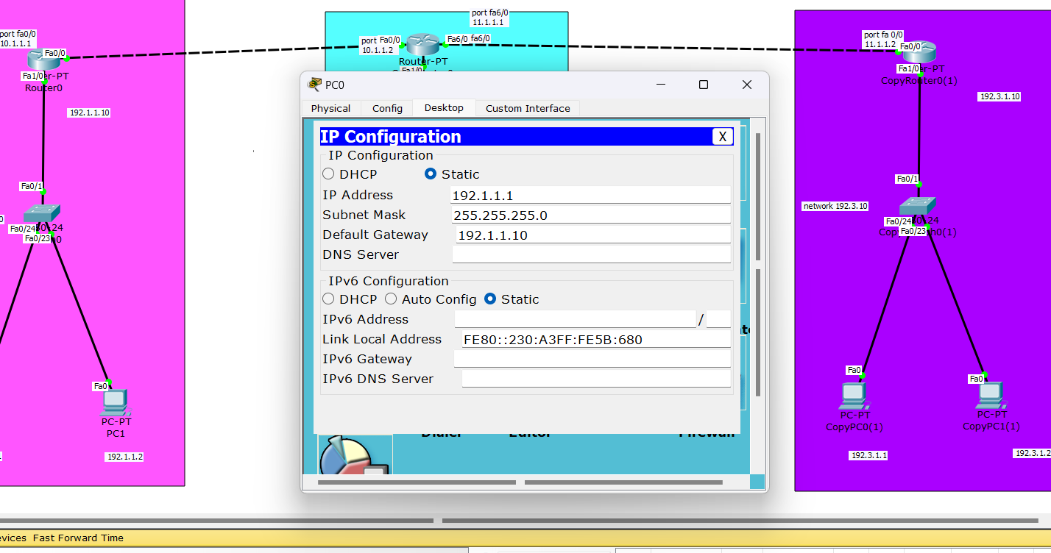

First set all ip addresses for the pcs as static and define their gateway

After configuring routers we can see that transmission is success.

The above shows the commands for the routers hence our network is connected.